PROJECT-REPORT:

POLITICAL JUGGERNATUR: A QUANTITATIVE ANALYSIS OF CANDIDTES IN THE 2019 LOK SABHA

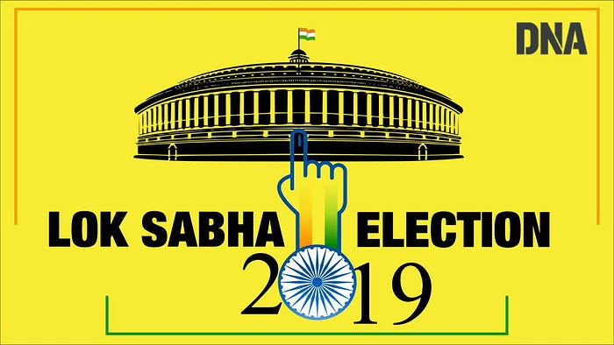

TEAM ID (NM2023TMID06321)

TEAM MEMBERS:

D.SANJAY (asumn1319222104947)

R.MUTHUVEL (asumn1319222104935)

E.NEELAMEGAN (asumn1319222104936)

M.KRISHNA (asumn1319222104933)

**1.INTRODUCTION**

## 1.1 OVERVIEW:

The election resulted in a landslide victory for the BJP which won 303 seats and formed the government. Around 912 million people were eligible to vote, and voter turnout was over 67 percent – the highest ever, as well as the highest ever participation by women voters.

## 1.2:Purpose:

The **Lok Sabha**, or **House of the People**, is the [lower house](https://en.wikipedia.org/wiki/Lower_house" \t "_blank) of [India](https://en.wikipedia.org/wiki/India" \t "_blank)’s [bicameral](https://en.wikipedia.org/wiki/Bicameralism" \t "_blank) [Parliament](https://en.wikipedia.org/wiki/Parliament_of_India" \t "_blank), with the [upper house](https://en.wikipedia.org/wiki/Upper_house" \t "_blank) being the [Rajya Sabha](https://en.wikipedia.org/wiki/Rajya_Sabha" \t "_blank). [Members of the Lok Sabha](https://en.wikipedia.org/wiki/Member_of_Parliament,_Lok_Sabha" \t "_blank) are elected by an adult [universal suffrage](https://en.wikipedia.org/wiki/Universal_suffrage" \t "_blank) and a [first-past-the-post](https://en.wikipedia.org/wiki/First-past-the-post" \t "_blank) system to represent their respective [constituencies](https://en.wikipedia.org/wiki/List_of_constituencies_of_the_Lok_Sabha" \t "_blank), and they hold their seats for five years or until the body is dissolved by the [President](https://en.wikipedia.org/wiki/President_of_India" \t "_blank) on the advice of the [council of ministers](https://en.wikipedia.org/wiki/Union_Council_of_Ministers" \t "_blank). The house meets in the Lok Sabha Chambers of the [Sansad Bhavan](https://en.wikipedia.org/wiki/Parliament_House_(India)" \t "_blank), [New Delhi](https://en.wikipedia.org/wiki/New_Delhi" \t "_blank).

2.Proplem Definition & Design Thinking

## 2.1 Empathy map:

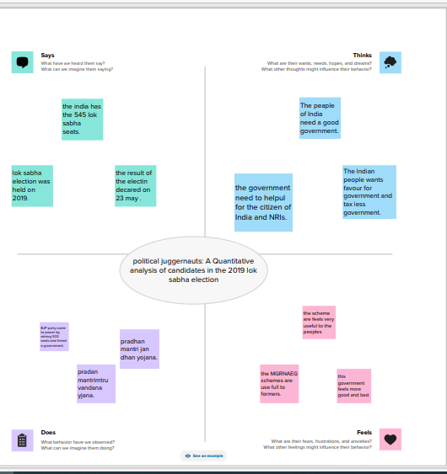

## 2.2:Ideation & Brainstorming Map:

: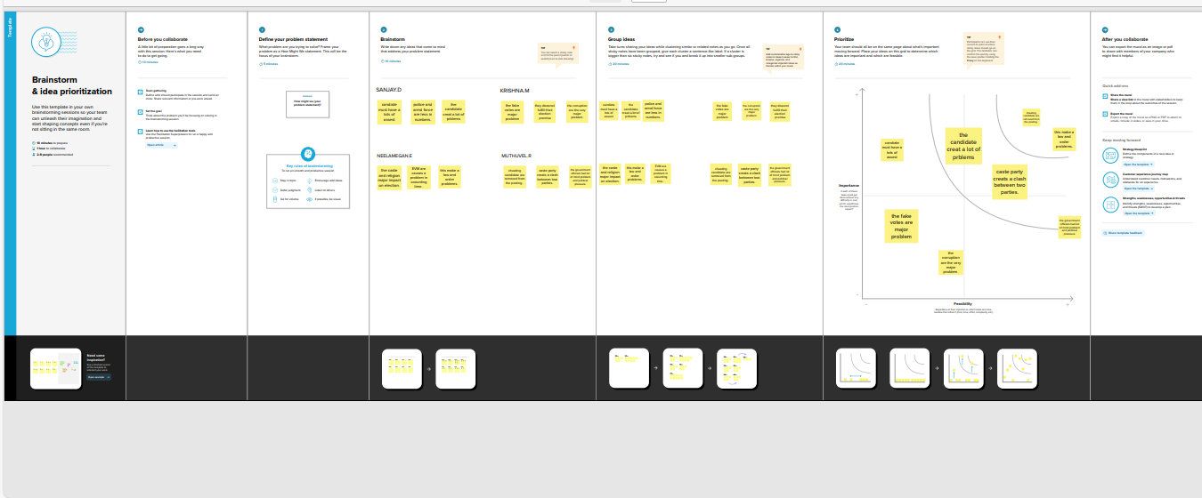

## 3:RESULTS:

Using tableau political juggenaur : a quantitative analysis of candidtes in the 2019 lok sabha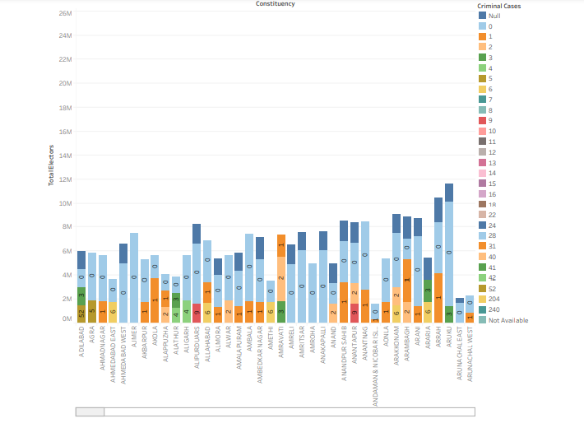

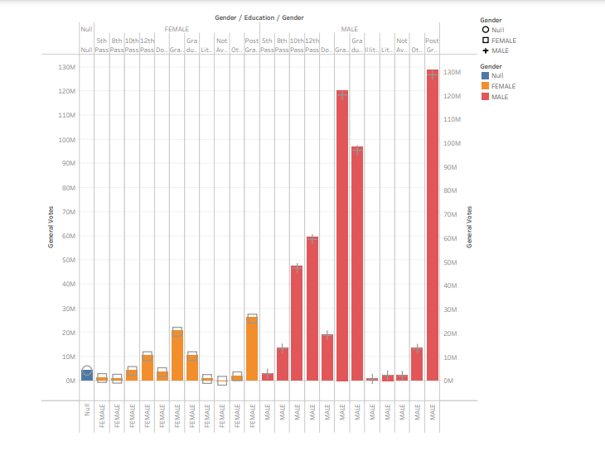

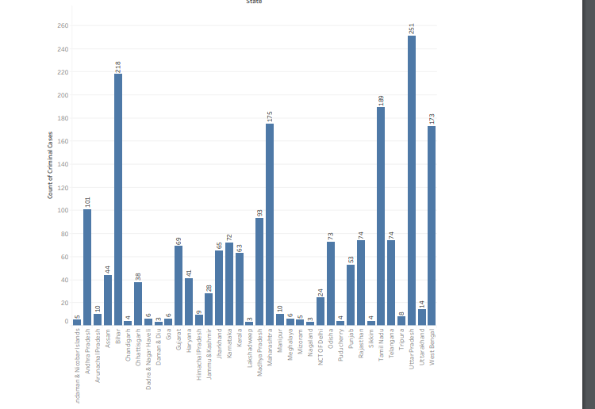

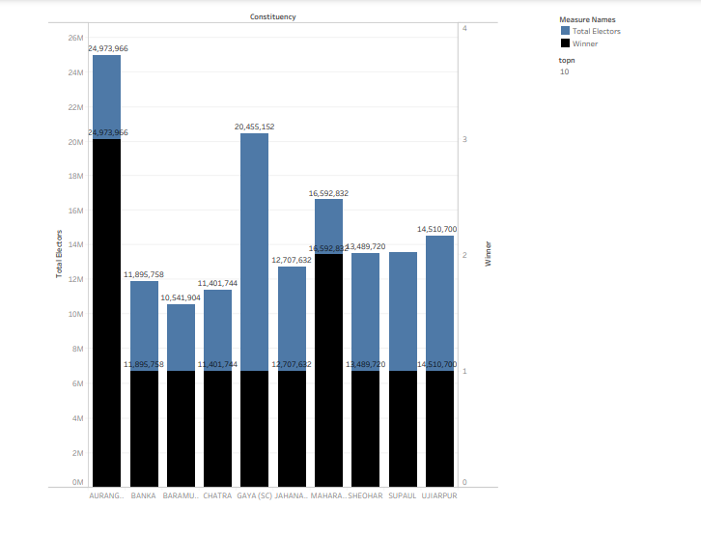

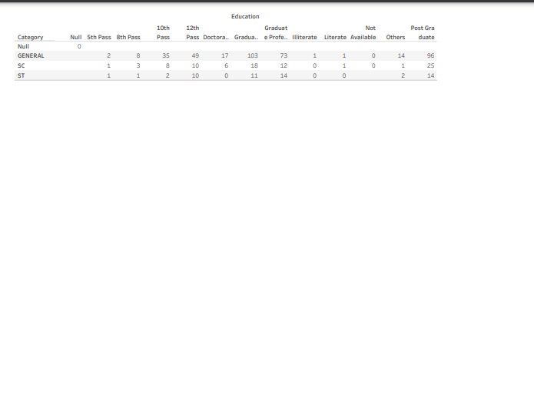



DASHBOARD:

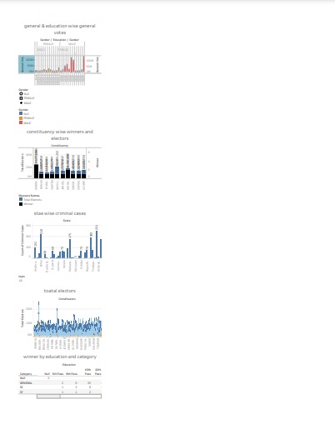

## STORY:

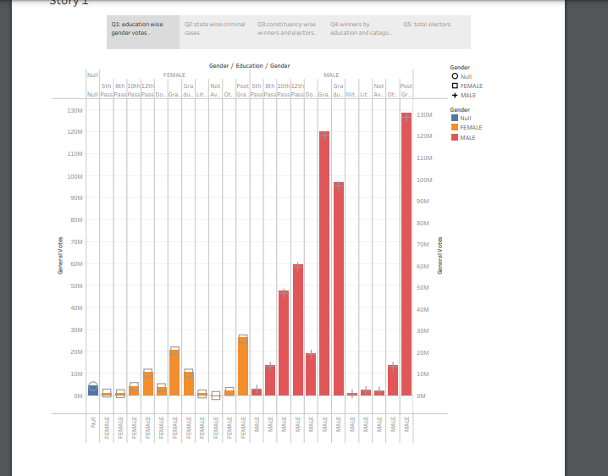

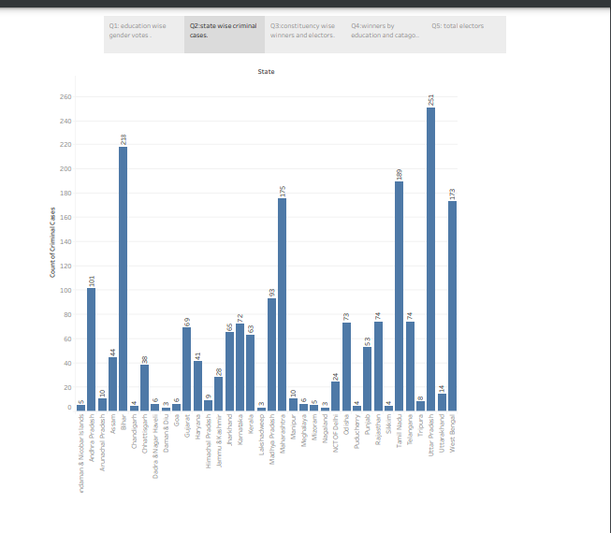

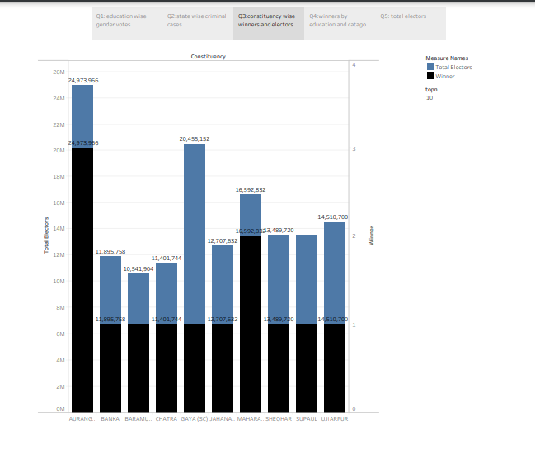

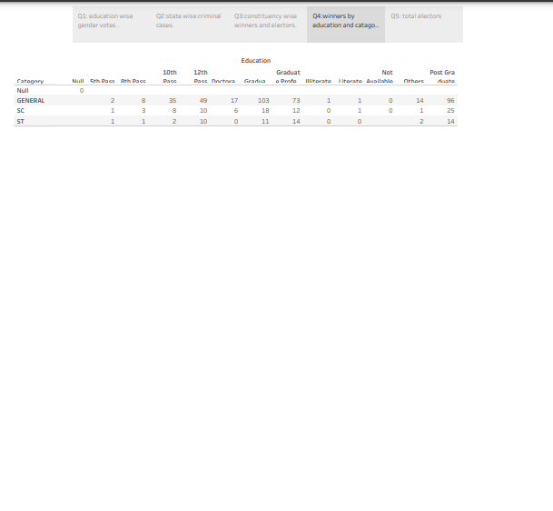

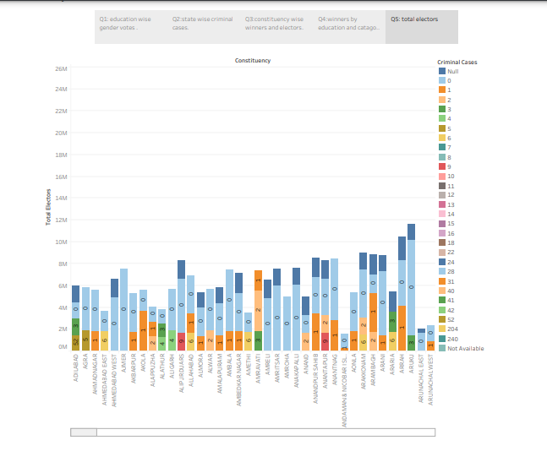

## 4:ADVANTAGES & DISADVANTAGES

## #ADVANTAGES:

\* The Supreme Court on Friday rejected a plea seeking a direction to the Election Commission (EC) to advance polling timing to 5:30 AM from 7 AM for seventh phase of the Lok Sabha election in view of searing heat and Ramzan.

\* When the counsel referred to the searing heat in parts of the country, especially between 12 noon to 3 PM, the bench said, “The timings are from 7 AM to 6 PM. People can come in the morning to cast their votes.”

\* The petitioner had said harsh weather conditions would make it difficult for Muslims to go out and vote.

## #DISADVANTAGES:

\* Members of the Lok Sabha often vote along party lines due to the strong influence of political parties and the whip system. This can lead to reduced independent thinking and decision-making, as members might prioritize party interests over the interests of their constituents.

\* The prevalence of dynastic politics, where family members of established politicians enter politics and secure positions in the Lok Sabha, can hinder the emergence of new and diverse leadership, potentially limiting fresh ideas and perspectives

\* There have been instances of money and corruption influencing the functioning of the Lok Sabha, such as allegations of bribery and unethical practices in lobbying.

## APPLICATIONS :

1. Name and full address of the applicant
2. Whether the advertisement is by a political party / contesting candidate / any other person / group of persons / association / organization / Trust (give the name)
3. Address of Headquarters of political party / group or body of persons / association / organization / Trust

## 5.CONCLUSION:

1. Elections for the 17th Lok Sabha concluded successfully. The election for 542 seats was held in seven phases.  Overall around 70 percent polling was recorded in all the phases.
2. Briefing media in New Delhi, Deputy Election Commissioner Umesh Sinha said that people, including women and senior citizens, came out in large numbers to exercise their franchise.
3. He said polling was by and large peaceful barring some incidents of violence. He added that this year's general elections were more peaceful as compared to the 2019

## FUTURE SCOPE:

**A research [paper](https://papers.ssrn.com/sol3/papers.cfm?abstract_id=4512936) by Ashoka University scholar Sabyasachi Das, titled ‘Democratic Backsliding in the World’s Largest Democracy’ seems to have stirred the hornet’s nest in certain political circles.**